# Software Requirements Specification for “BlitzTix” And X Entertainment

**PREPARED FOR**

And X Entertainment

**PREPARED BY**

Collin Snyder, Lucy Davidson, Kyle Josephson, Katelyn Borne, Jamie Hurd

Brigham Young University - Idaho

# Table Of Contents

**Software Requirements Specification for “BlitzTix” And X Entertainment** **1**

**Table Of Contents** **2**

**1 - Introduction** **4**

1.1 Purpose 4

1.2 - Scope 4

1.2.1 In Scope 4

1.2.2 Out of Scope / Future Wants 5

1.3 Product Overview 5

1.3.1 Product Perspective 5

1.3.2 Product Function 5

1.4 - Definitions 6

**2 - Specific Requirements** **7**

2.1 - Database 7

2.1.1 Types of Information 7

2.1.2 Frequency of Use 8

2.1.3 Accessing Capabilities 8

2.1.4 Data Entities and Their Relationships 8

2.1.5 Integrity Constraints 8

2.1.6 Data Retention Requirements 8

2.2 - Functions 9

2.2.1 Users & Customers 9

2.2.1.1 Allow User Log In 9

2.2.1.2 User Profile Information 9

2.2.1.3 Allow User Sign Up 9

2.2.1.4 User/Customer Create Event (Admin/Venue) 9

2.2.2 Register for Event 10

2.2.2.1 User Venue Selection 10

2.2.2.2 User Selects Seating 10

2.2.2.3 User Ticket Purchase 11

2.2.2.4 Ticket Confirmation / Proof of Sale 11

2.2.2.5 Complete User Reservation 11

2.2.3 Event Execution 11

2.2.3.1 Start Event 11

2.2.3.2 Get QR Registration 11

2.2.3.3 Check In 11

2.2.4 Current/Post Event 12

2.2.4.1 Check Attendance 12

2.2.4.2 Data Feed 12

2.2.4.3 Reports 12

2.2.4.4 Analytics 12

2.3 Usability Requirements 12

2.4 Performance Requirements 13

2.4.1 Application Loading Time 13

2.5 Design Constraints 13

2.5.1 OS Constraints 13

2.5.2 Internet Connection 13

**3 - Verification** **13**

3.2.2.1 User Login verification 13

3.2.1.2 User Profile Information 13

3.2.1.3 Allow User Sign up 14

3.2.1.4 User/Customer Create Event 14

3.2.1.6 User Venue Selection 14

3.2.1.7 User Selects Seating 14

3.2.1.8 User Ticket Purchase 14

3.2.1.9 Ticket Confirmation/Proof of Sale 14

3.2.2.0 Complete User Reservation 15

3.2.2.1 Start Event 15

3.2.2.2 Get QR Registration 15

3.2.2.3 Check-In 15

3.2.2.4 Check Attendance 15

3.2.2.5 Data Feed 15

3.2.2.6 Reports 15

3.2.2.7 Analytics 16

**4 - Appendices** **16**

4.1 Assumptions and Dependencies 16

# 

# **1 - Introduction**

## 1.1 Purpose

This document is written to convey information pertaining to a ticket registration system for BlitzTix events.

This document contains the criteria that will need to be met in order for this system to be considered complete and successful.

This document is written for fellow developers and clients. The goal is to gather as much important information as possible in order to get detailed requirements for the development of the system. To gather information, we have had an initial meeting with the General Manager of And X, Andy, and he described for us the requirements that he holds in the highest priority.

The current requirements given by the client suggest that this registration system will be designed to assist users with picking seating selections and registering for individual tickets at various events. This registration system will vary from the competitors in that it will be cheaper for various venues to adopt and additional money will go back to venues and additional securities in their registration systems.

## 1.2 - Scope

The registration system will receive specific data from user input on the website in order to retain that data for regular access. The data will be saved to a user profile so that specific information can be accessed at any time by the user. The system will allow for attendees to view a map of the venue and select their seating or seating blocks. The system will have varying levels of accessibility for various kinds of users, i.e. administration, venue owners, promoters, and attendees. The system will also be able to analyze events and generate regularly scheduled reports.

### 1.2.1 In Scope

* Registration System software requirements
* System functionality
* System’s database requirements
* System’s ability to connect to third party applications
* Seating Selection
* User Login (Admin, Venue, Promoter, Attendee)
* Ticket Check in (QR/Barcode)
* Data feedback (reports/analytics)

### 1.2.2 Out of Scope / Future Wants

* System security
* Specific third party applications functionality
* Specific requirement elicitation data
* Hardware functionality
* Ticket Validation
* App
* Apple/Android wallet Integration
* Virtual/Broadcast Ticket
* Seperate names for multiple purchases

## 1.3 Product Overview

### 1.3.1 Product Perspective

There are several other systems that have already been created that act as a registration system, however, their security is lacking and yet these other systems are still rather expensive for any venues and companies to use.

### 1.3.2 Product Function

The general functions of this system are to give users an easier experience while selecting their seating arrangements and obtaining tickets for various events and venues. The user will then be able to interact with the website as shown below: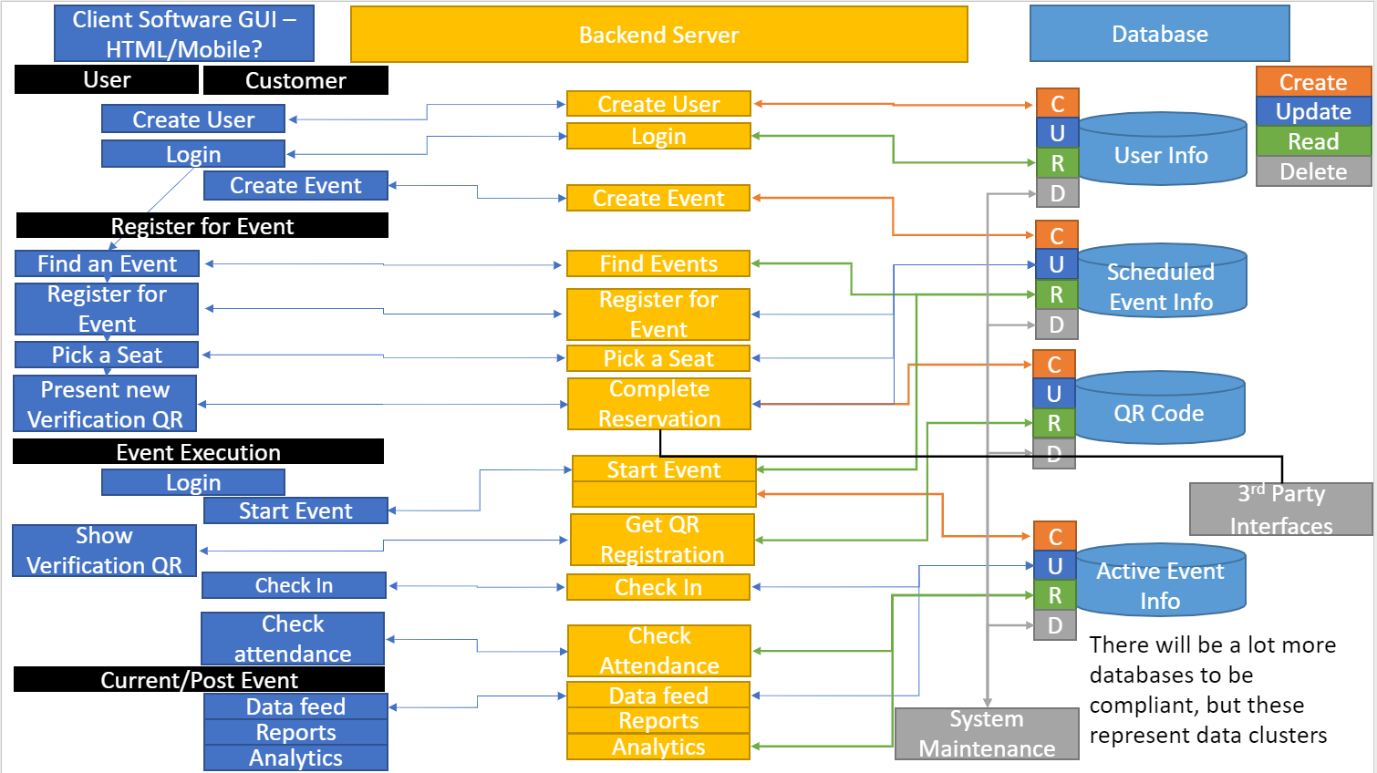

## 1.4 - Definitions

| Term | Definition |
| --- | --- |
| Admin Level | Administration level of access above that of a normal user's abilities on the given system, BlitzTix management will have the admin level access |
| Attendee | A person who attends an event or other gathering. |
| Attendee Level | Access to the systems’s services at the basic level of one who is only attending a BlitzTix event. |
| Barcode | A machine-readable code in the form of numbers and a pattern of parallel lines of varying widths, printed on and identifying a product. |
| Block | An arrangement of 3 to 10 seats together at a venue. |
| Client | A person or organization using the services of the company. |
| Customer | A person or organization that buys goods or services from BlitzTix |
| Database | Collection of all the information monitored by this system. |
| Developer | A person or thing that helps in the creation of the registration system used by BlitzTix |
| Map | Depiction of seats available at various venues |
| Permission | Consent or authorization |
| Promoter | A person or company that finances or organizes an event or production. |
| Promoter Level | Access permissions given only to those that organize events |
| QR code | A machine-readable code consisting of an array of black and white squares, typically used for storing URLs or other information for reading by the camera on a smartphone. |
| Software Requirements Specification | A document that completely describes all of the functions of a proposed system and the constraints under which it must operate. |
| Stakeholder | Any person with an interest in the project who is not a developer. |
| Ticket | A piece of paper or small card that gives the holder a certain right, especially to enter a place, travel by public transport, or participate in an event. |
| User | Someone visiting the site to obtain a ticket or any information. |
| Validation | The action of checking or proving the validity or accuracy of something. |
| Venue | the place where something happens, especially an organized event such as a concert, conference, or sports event. |
| Venue Level | Access permissions given only to those that own or operate a venue that BlitzTix events are held at at the present time |

# **2 - Specific Requirements**

The system will run through the BlitzTix website.

It should also be compatible with the websites of the venues that are available for events.

## 2.1 - Database

A database shall be used for web based storage of any gathered information. The database shall also be able to access all necessary information. The database shall include tables that will specify information the various functions require.

#### 2.1.1 Types of Information

The types of information used in the database shall be numbers, var, chars, hashes, arrays, and booleans. The function to enter a name and password shall use a varchar and a hash. The seat information shall be an object that is stored in an array, which shall contain QR code information.

#### 2.1.2 Frequency of Use

The database shall be made available as much as possible when the provider is not updating. The database shall have a maximum 750 hour usage limit per month.

#### 2.1.3 Accessing Capabilities

The database shall provide 5 or less users to access the data at the same time. Ober 5 users is not a guarantee that the data will be accessible.

#### 2.1.4 Data Entities and Their Relationships

The following tables shall be created to store data. Relationships in the data shall be made with a PRIMARY KEY and FOREIGN KEY.

* User Table
* Venue Table
* Event Table
* Section Table
* Seats Table

The Event Table shall have a FOREIGN KEY from the Venue Table. The Section Table shall have a FOREIGN KEY from the Venue Table. The Seats Table shall have FOREIGN KEYS from the Venue, User, Event, and Section Tables.

#### 2.1.5 Integrity Constraints

The database shall be kept secure by a professional company who manages databases. Encryption shall be used on all data.

#### 2.1.6 Data Retention Requirements

The data at rest shall be kept as safe as possible by the professional management company and shall be available when the data is requested by the system. Back-up of the database would be recommended, but is not required.

## 2.2 - Functions

### 2.2.1 Users & Customers

#### 2.2.1.1 Allow User Log In

When a user visits the website, they may interact with the site as a guest. When they attempt to purchase tickets or seating at any venue, they will be prompted to log in to the website. After logging in, the user will be displayed all their personal information and data about past transactions on the website. [3.2.1.1]

#### 2.2.1.2 User Profile Information

When the user logs into their account on the BlitzTix website, they will be presented with a User Profile which displays their name, first and last, their address, email, and phone number. It will also display their past transactions including:

* Visited venues
* Attended events

[3.2.1.2]

#### 2.2.1.3 Allow User Sign Up

When a user visits the website, they may interact with the site as a guest, but when they attempt to purchase tickets or seating at any venue, they will be prompted to log in to the website. If they do not already possess an account with BlitzTix, they will be prompted to create a free account. During this process of signing up, users will be asked for the following information:

* First Name
* Last Name
* Address
* Email
* Phone Number
* Password

[3.2.1.3]

#### 2.2.1.4 User/Customer Create Event (Admin/Venue)

Customers will be able to specify the time and location of the event they would like to hold. Customers will also be asked to specify what kind of event they plan to hold and the range of time, including:

* Preparation / setup
* Event beginning
* Event ends
* Take down / clean-up time

[3.2.1.4]

### 2.2.2 Register for Event

#### 2.2.2.1 User Venue Selection

When a user selects an event that they are interested in attending, they will be given a list of the possible venues at which the event could take place. The user will then make a selection of their preferred venue. After venue selection, they will be given the option to select their preferred seating arrangements. [3.2.1.6]

#### 2.2.2.2 User Selects Seating

When a user selects their desired venue they will be shown the seating map available at that venue. On this map, the seat available will be shown in color, while seats that are taken or otherwise unavailable will be shown in a lighter grey, or shown with an X. User’s can purchase seats individually or in blocks, meaning between 3-10 at a time. [3.2.1.7]

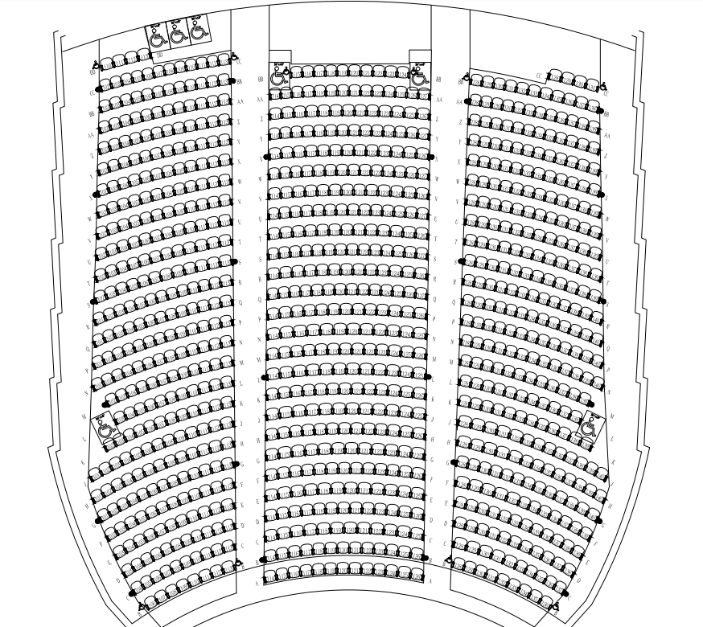

#### 2.2.2.3 User Ticket Purchase

When the user selects their seat, or block of seats, they will be taken to a confirmation screen and be asked for their credit card information for ticket purchase.

* Name on the credit/debit card
* Credit/debit card number
* Security code
* Expiration date

[3.2.1.8]

#### 2.2.2.4 Ticket Confirmation / Proof of Sale

After a user pays for their tickets they will receive a QR code on their user account to show proof of purchase when checking into an event/venue. A pop-up screen will also be displayed upon purchase showing the QR code. [3.2.1.9]

#### 2.2.2.5 Complete User Reservation

When the user submits their purchase, that information will be stored in the database and update the availability for seating/tickets remaining for the venue. [3.2.2.0]

### 2.2.3 Event Execution

#### 2.2.3.1 Start Event

When an event is beginning the setup process, the venue owner and the promoter are permitted to access this portion of the website in order to record that the event is beginning. This is helpful in tracking the length of time of each event and the length of use for every venue. Recording such information is helpful in charging promoters and attendees. [3.2.2.1]

#### 2.2.3.2 Get QR Registration

When a user purchases a ticket, they are given a QR code associated with their ticket confirmation. This QR code is logged into a database that is connected to the user’s information for use at the time of the event so that checking an attendee in is easy and efficient. This QR code should be accessible from any mobile device with an internet connection. It will also be tied to the time of the event and the user’s seating selection. [3.2.2.2]

#### 2.2.3.3 Check In

When the event begins, users and customers that choose to attend the event can do so by showing a ticket confirmation email or a given QR code to the check in station at the venue that they have selected. The QR code that is used for check in can be printed or found on the website under the user’s account after a purchase has been made. [3.2.2.3]

### 2.2.4 Current/Post Event

#### 2.2.4.1 Check Attendance

The venue owner and operator will have an accessibility level on the website such that after an event has begun, they can regularly check the attendance level. They will be given a total number of tickets purchased and an update on the number that have checked in in half hour increments as long as the owner has a device with an internet connection. [3.2.2.4]

#### 2.2.4.2 Data Feed

Data feed will gather info on venues for BlitzTix. Information such as user age, volume of attendants, where the event is held, when tickets are bought, price of tickets, and event type will be recorded. [3.2.2.5]

#### 2.2.4.3 Reports

After an event has ended and venue owners have marked the venue as ready for the next event, they are able to access a report of the event. The report will include information such as:

* Number of people that checked in
* Number of people that bought tickets but did not attend
* Time the event began
* Time the event officially ended

[3.2.2.6]

#### 2.2.4.4 Analytics

Analytics will display the information from the Data Feed function for BlitzTix to review. Weekly, monthly, daily, and quarterly reviews will be available for Admin eyes with limitations to Venue hosts. [3.2.2.7]

## 2.3 Usability Requirements

* The website shall clarify errors upon inputting data into form fields.
* Thumbnail images shall symbolize the activity it is representing.
* The user shall comprehend the symbols on the icons in 3 milliseconds, or less.
* The user shall comprehend the labels on the icons in 3 milliseconds, or less.
* The user shall not be distracted by tabs, icons, or buttons disrupting the content on the website.

## 2.4 Performance Requirements

#### 2.4.1 Application Loading Time

The application loading time for any given page should take no longer than 10 seconds to load to allow for user satisfaction.

## 2.5 Design Constraints

#### 2.5.1 OS Constraints

The website shall be compatible with the following current versions of operating systems:

* Microsoft Windows
* Apple macOS
* Linux
* Android
* Apple's iOS

#### 2.5.2 Internet Connection

* The website will need an internet connection to synchronize all the given and received data.
* The app will not ask for permission before using mobile data to function properly, accessing the website assumes the user gives permission for mobile data to be used.

# **3 - Verification**

#### 3.2.2.1 User Login verification

The user is able to log in either by guest, or using credentials set up within the app, (username and password) and successfully gain access to purchasing tickets within the app. If a login is not successful, the user will not be able to purchase tickets. [2.2.2.1]

#### 3.2.1.2 User Profile Information

The user will be prompted to log in using their credentials (username and password), and successfully access their user profile with all associated information. If the login is not successful, the user profile will not be accessible. [2.2.1.2]

#### 3.2.1.3 Allow User Sign up

The user will be prompted to sign up and create an account so tickets can be purchased. The user will enter all information that is requested in the sign up page, and the user is able to successfully register and obtain tickets. If the user sign up is not successful, the user will not be able to purchase tickets within the application. [2.2.1.3]

#### 3.2.1.4 User/Customer Create Event

User identifies the time and location of the event and the associated results will appear. If the user wants to create an event, they click on the Create Event button and are taken to a new activity, asking for specific details of the event. Once completed, a pop up message will appear that the event has been created. An email will also be sent to the users associated email verifying the event. [2.2.1.4]

#### 3.2.1.6 User Venue Selection

The user is presented with a list of events, and clicks on the Register button to verify their registration for that given event. Once the selection is made, a confirmation page will appear to let the user know the action is completed, and a confirmation email will be sent. [2.2.2.1]

#### 3.2.1.7 User Selects Seating

The user will click on the event, and they will be shown a seating map of the venue, the user will be able to pick their desired seat if it is highlighted. If the seat is unavailable, it will not be highlighted. [2.2.2.2]

#### 3.2.1.8 User Ticket Purchase

Once the user selects their seat, they will be taken to a confirmation page prompting them to enter their financial information to complete the transaction. [2.2.2.3]

#### 3.2.1.9 Ticket Confirmation/Proof of Sale

Once the user enters in their financial information, they will select the Submit button to complete their purchase. Once completed, a confirmation page will appear confirming the purchase amount and date and time of the event. [2.2.2.4]

#### 3.2.2.0 Complete User Reservation

Upon completion of the required reservation fields, the user selects the complete reservation button. Once completed, a confirmation toast appears notifying the user of a successful or failed completed reservation.

[2.2.2.5]

#### 3.2.2.1 Start Event

The user is able to record that the event has started using their security level clearance. Once the event has started, the page will display that the event is starting and tracks the length of time of the event. [2.2.3.1]

#### 3.2.2.2 Get QR Registration

Once a user has purchased a ticket, the page will display a designated QR code representing their purchased ticket. The QR code will be accessible within the users profile under Events. [2.2.3.2]

#### 3.2.2.3 Check-In

The user will display the given QR verification code for their event, and the venue will scan the code, and the user will successfully be checked into the event. [2.2.3.3]

#### 3.2.2.4 Check Attendance

The venue owner and operator will have special security clearance to view the attendance level and how many users have checked into the event. It will update every half hour throughout the event. [2.2.4.1]

#### 3.2.2.5 Data Feed

Data feed acquires and stores data on attendance and the attendee upon check-in of the attendee at the given event.

[2.2.4.2]

#### 3.2.2.6 Reports

The venue owner will be able to access a full report of the event by clicking on the Event Report, and the analytics associated with it will be displayed. [2.2.4.3]

#### 3.2.2.7 Analytics

The graphical data and numbers from the Data Feed function will be displayed for Admins.

[2.2.4.4]

# **4 - Appendices**

## 4.1 Assumptions and Dependencies

* The user understands how to operate basic functionality of electronics.
* The user has a credit or debit card capable of web transactions.
* The user owns a device capable of accessing the web.
* The user has an email.